Kids and Horses 2019 Summer Beginner Horseback Riding Camp! Kids LOVE Horses and these camps combine riding and learning with a whole lot of FUN! Come join us for 4 days of learning and riding horses. KidsandHorses.net
June 3,4,5,6
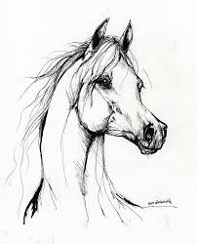
June 24,25,26,27 & July 15,16,17,18
Summer Camp 9am -4pm Monday – Thursday $425. C a Camp closes 5 days before camp begins or $40 late fee. Camps space is limited and fill up fast first-come, first-serve basis. R e Reserve Your Saddle Soon! Camp cancelation due to weather will be rescheduled. $50. Nonrefundable Deposit on cancellations.
Camper’s Name: _______________________ Age____ Phone: _____________
Camps are held in an indoor arena off of Highway 83 S. Parker Rd. @ K and H Stables 7062 Rafter Road Franktown, CO. 80116.
Sign up at Kidsandhorses.net or mail Registration Form with payment: Kids and Horses 5221 Stone Canon Ranch Rd Castle Rock, Co. 80104 Mailing address only! ortond@msn.com
These materials are neither sponsored nor endorsed by Douglas County School District, . Superintendent, its board, or this school.

